Final Assessment-Alternative Assessment
Semester | 202520 | Division | CIS
Assessment title in Syllabus | Final_Project_Portfolio | Program | Bachelor of Information Technology/ Bachelor of Information Systems
Course Code | CDS 2413
Course Title | INTRODUCTION TO DATA SCIENCE
Course Instructor |  | CRN
Assessment | Project Deliverable 2 – Machine Learning Model Report | Submission Date | Week 13
Student Declaration:
Academic Integrity Statement
In accordance with the HCT Academic Integrity Policy
• Students are required to refrain from all forms of academic integrity breaches as defined and explained by HCT.
• A student found guilty of having committed acts of academic integrity breach(es) will be subject to the relevant sanctions as outlined by HCT.
إفادة النزاهة الأكاديمية
وفقًا لسياسة كليات التقنية العليا للنزاهة الأكاديمية
• على الطلبة الإلتزام بلوائح وقواعد النزاهة الأكاديمية، كما هو مبيّن وموضح في السياسات والإجراءات الخاصة بكليات التقنية العليا.
• في حالة ارتكاب الطالب أي شكل من أشكال الإخلال بالنزاهة الأكاديمية، سيتعرض الى العقوبات الموضحة في السياسات ذات الصلة.
This assignment is entirely my/our own work except where I have duly acknowledged other sources in the text and listed those sources at the end of the assignment. I have not previously submitted this work to the HCT, or any other entity. I understand that I may be orally examined on my submission.

Student HCT ID(s): | H00 | H00 | H00 | H00
Student Name(s):
Student Signature
Chatbot (e.g. ChatGPT) statement
This submission allows you to use AI generated tools, but the prompt used must be stated and the response must be in red font. Include References to ChatGPT.

Instructions

Remove instructions and hints from the template before submitting the final report to BBLearn.

CLO3: Machine Learning Model (25 Points)

Preprocessing(5 Points)

Data Collection (1 Point)
<< Which Python libraries can be used to read data from CSV or Excel files? How will you identify and separate the dependent and independent variables from the dataset? >>
In this project, we used Python libraries to load and analyze the dataset.
The main libraries used for reading the dataset were:
- Pandas – used to read and manipulate datasets
- NumPy – used for numerical calculations
Using Pandas, we loaded the dataset file studentperformancefactors.csv.
Pandas provides functions like:
- read_csv() → to read CSV files
After loading the dataset, we separated the independent variables (X) and dependent variable (y).
- Independent variables (X) are the input features that influence the result.
- Dependent variable (y) is the output that we want to predict.
In our dataset:
Target variable:
Exam_Score
Independent variables:
Hours_Studied, Attendance, Motivation_Level, Sleep_Hours, etc.
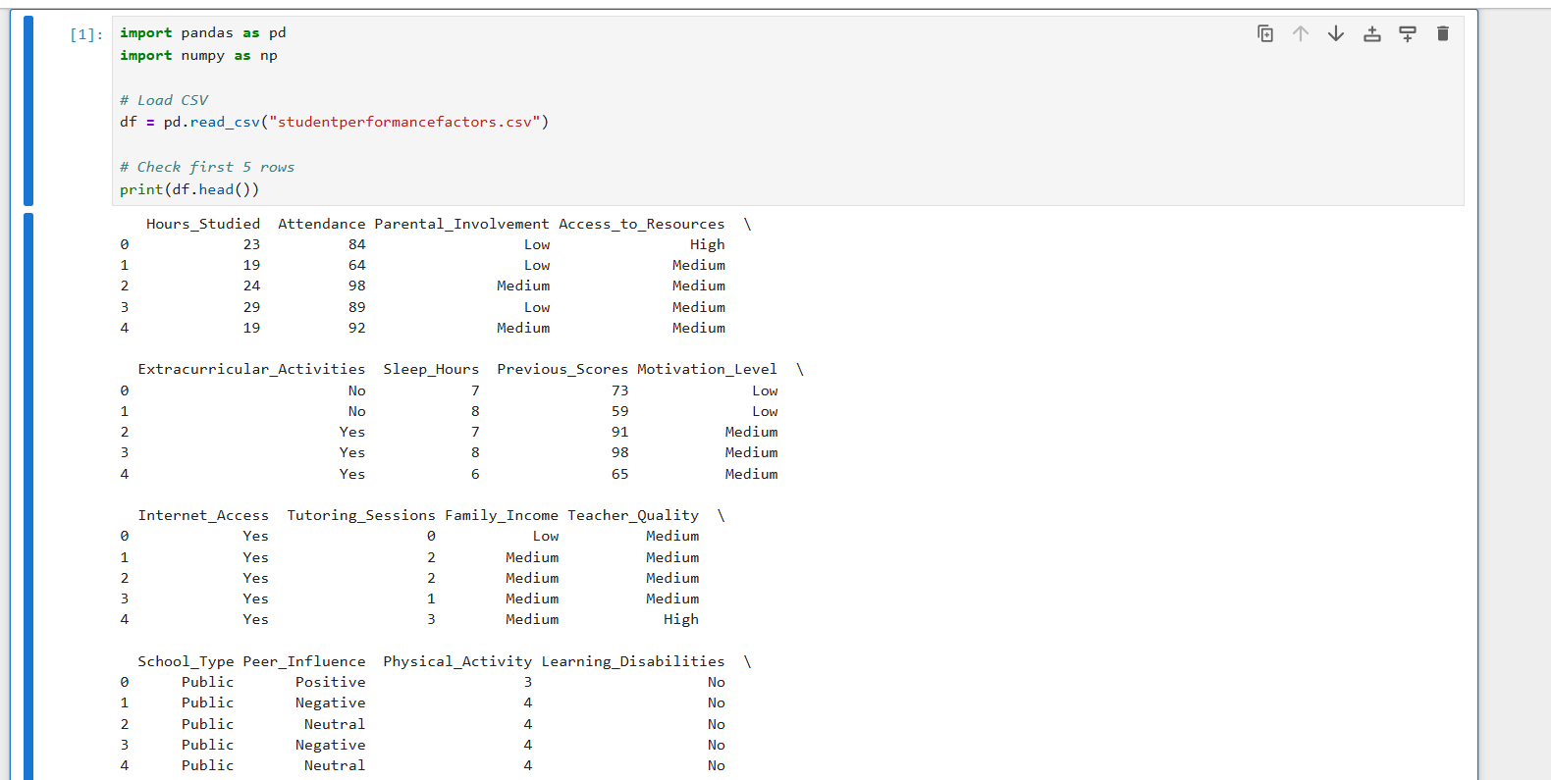

Data Cleaning (1 Point)
<< What strategy or strategies did you use to clean your dataset? Provide examples, such as filling missing values with the mean or removing duplicates.>>

Data cleaning is important because real-world datasets may contain:
- Missing values
- Incorrect values
- Duplicate records
- Outliers
In our project, we applied the following strategies:

1. Handling Missing Values
We checked for missing values using:
df.isnull().sum()
Then we filled missing values using:
- Mean for numerical columns
- Mode for categorical columns
Example:
df[col] = df[col].fillna(df[col].mean())
df[col] = df[col].fillna(df[col].mode()[0])
This ensures that the dataset becomes complete and usable for modeling.
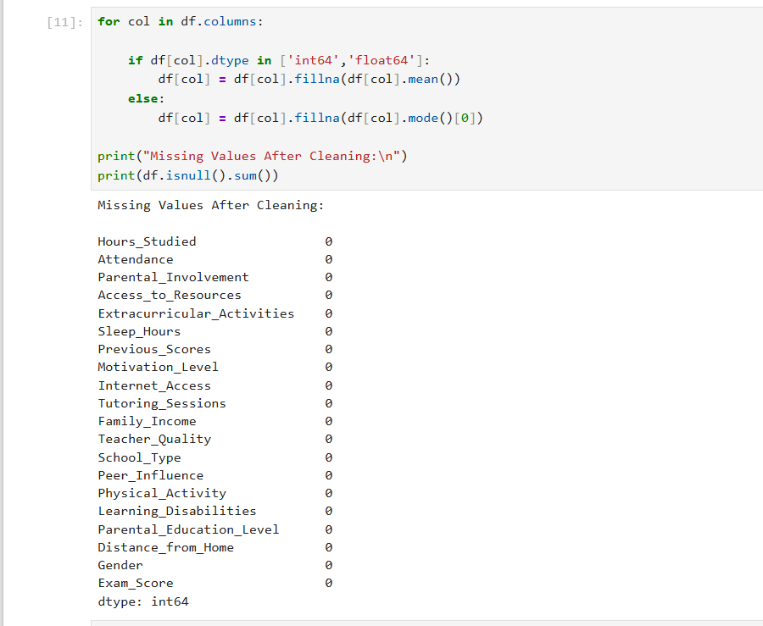

2. Removing Outliers
We used the Interquartile Range (IQR) method to detect outliers.
Formula used:
Lower Bound = Q1 − 1.5 × IQR
Upper Bound = Q3 + 1.5 × IQR
Any value outside this range was considered an outlier and removed.
This helps improve the performance of machine learning models.
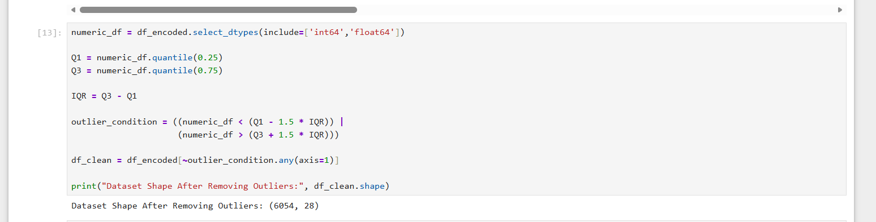

Treating the Categorical Variables (1 Point)
<< What types of categorical variables (nominal, ordinal, or binary) are present among your dependent and independent variables? What encoding technique did you use for these variables, and why?>>

Our dataset contained different types of categorical variables:

1. Binary Variables
Binary variables contain only two categories.
Example:
Gender → Male / Female
Internet_Access → Yes / No
For these variables we used Label Encoding, which converts categories into numbers.
Example:
Male → 1
Female → 0

2. Nominal Variables
Nominal variables have multiple categories with no specific order.
Example:
- School_Type
- Motivation_Level
- Peer_Influence
- Teacher_Quality
For these variables we used One-Hot Encoding.
Example:
School_Type_Private
School_Type_Public
This method prevents the model from assuming any ranking between categories.
Example code:
df_encoded = pd.get_dummies(df, drop_first=True)

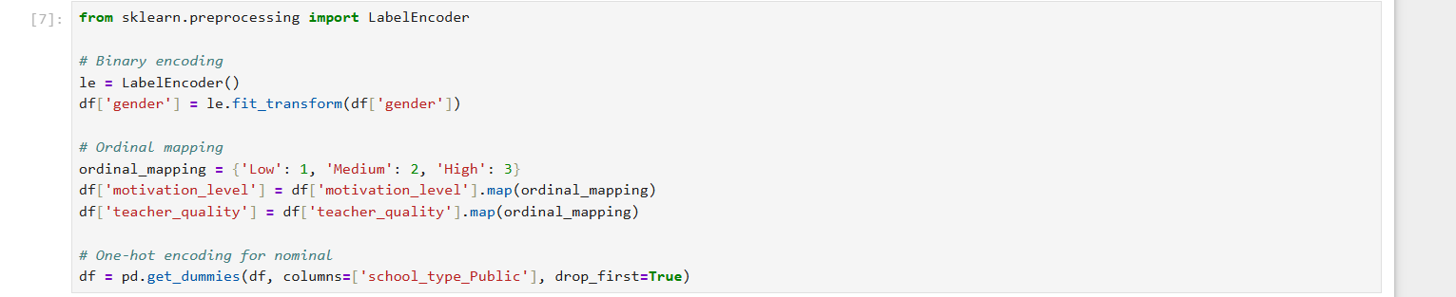

Splitting the Dataset (1 Point)
<< Why is it important to split the dataset during model development? What proportion did you use for training and testing, and why?>>

Splitting the dataset is important because it helps evaluate how well the model performs on unseen data.
If we train and test the model on the same data, the model may overfit and give unrealistic results.
Therefore, we divided the dataset into:
- Training data (80%)
- Testing data (20%)
Training data is used to train the model, while testing data is used to evaluate the model performance.
Example code:
from sklearn.model_selection import train_test_split
X_train, X_test, y_train, y_test = train_test_split(
X, y, test_size=0.2, random_state=42
)

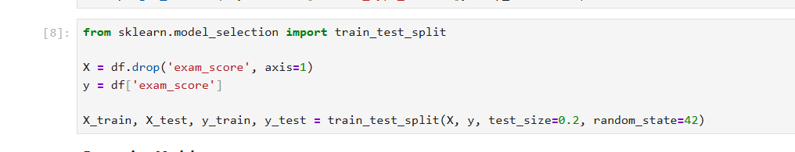

Featuring the Dataset (1 Point)
<< Did you apply feature scaling to your dataset? If so, which technique did you use, and why? If not, explain your reasoning.>>

Feature scaling is used when variables have different ranges.
In our dataset, most features are already within similar ranges, and regression models such as:
- Linear Regression
- Ridge
- Lasso
can work without mandatory scaling.
Therefore, we did not apply feature scaling in this project.
However, if algorithms such as KNN or SVM are used, scaling techniques like:
- Standardization
- Min-Max Scaling
can be applied to improve performance.

Regression Model (7 Points)

Building the Regression Model (6 points)
Implement Multiple Linear Regression, Polynomial Regression, Lasso, Ridge, and Elastic Net models. Select the best-fitting model based on evaluation metrics(R-squared). Analyze the model's performance by comparing predicted value with the actual values in the dataset.
In this project, we implemented multiple regression models to predict Exam_Score.
The models used were:
- Linear Regression
- Polynomial Regression
- Ridge Regression
- Lasso Regression
- Elastic Net Regression
These models were implemented using the Scikit-learn library.

Steps to be followed:

1. Loading and Preprocessing the Data
- Load Dataset:
  - The dataset (Marks.csv) is loaded using pandas.
  - Relevant columns (Quiz, Practical, Project, Final) are extracted for analysis.
- Handle Missing Values:
  - Missing values in the selected columns are replaced with their respective column means to ensure the dataset is complete and usable for modeling.
- Create Target Variable:
  - A new column, Total, is computed as a weighted sum of the independent variables:
    - Total = 0.1 * Quiz + 0.3 * Practical + 0.3 * Project + 0.3 * Final.
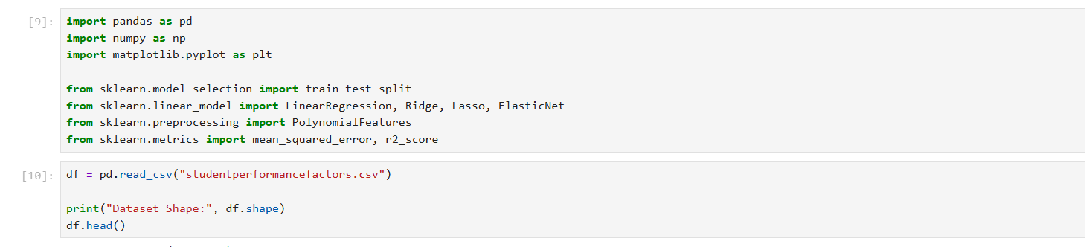
First we Loaded the dataset.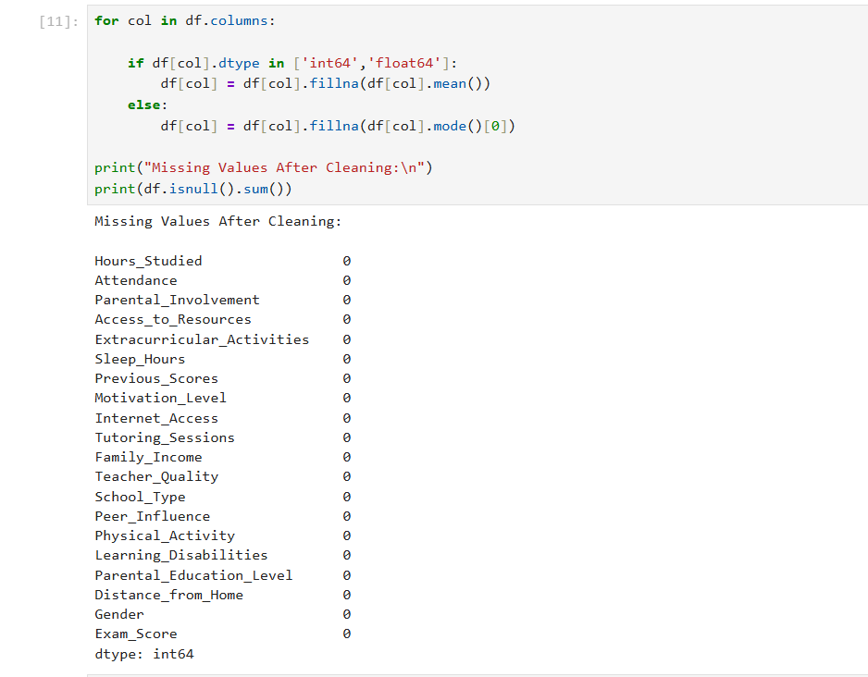
Then we clean the data by handling missing values
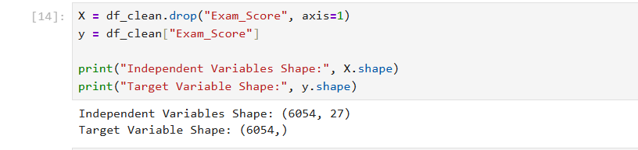

2. Detecting and Removing Outliers
- Outlier Detection:
  - For each independent variable (Quiz, Practical, Project, Final), outliers are identified using the Interquartile Range (IQR) Method:
    - Values outside [Q1 - 1.5*IQR, Q3 + 1.5*IQR] are flagged as outliers.
- Combine Outliers:
  - Outliers detected for all variables are consolidated into a single DataFrame and duplicates are removed.
- Remove Outliers:
  - Rows corresponding to the detected outliers are removed from the dataset to improve model performance.
We detect the outliers and then encoded them and print the shape of dataset after doing this which is (6054, 28)
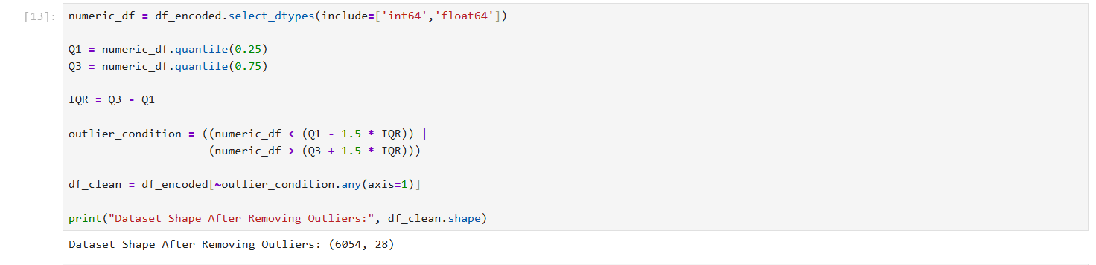

3. Splitting the Data
- Independent Variables (X):
  - The cleaned dataset’s independent variables: Quiz, Practical, Project, and Final.
- Target Variable (y):
  - The target variable Total.
- Train-Test Split:
  - The dataset is split into training (80%) and testing (20%) sets using train_test_split.
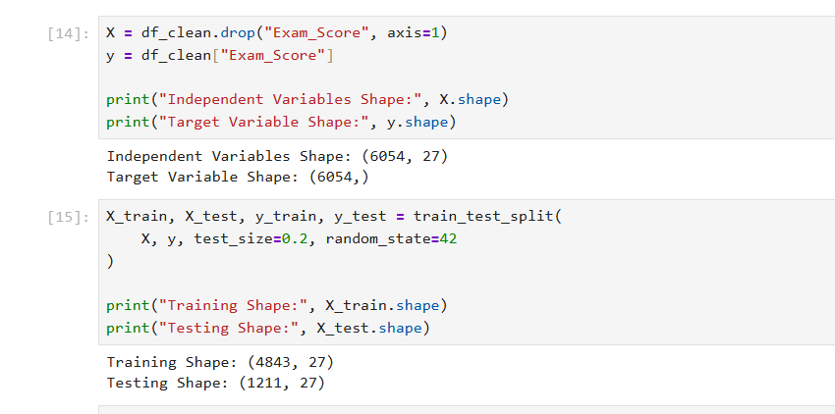
We followed the steps given and splitting the data.

4. Applying Regression Models
- Regression Models:
  - Multiple regression models are applied to predict the target variable Total:
    - Linear Regression:
      - Fits a straight line to the data.
    - Polynomial Regression (Degree 2):
      - Transforms features to include polynomial terms of degree 2.
    - Ridge Regression:
      - Linear regression with L2 regularization to reduce overfitting.
    - Lasso Regression:
      - Linear regression with L1 regularization for feature selection.
    - Elastic Net Regression:
      - Combines L1 and L2 regularization.
- Polynomial Features:
  - For polynomial regression, the features are transformed to include polynomial terms using PolynomialFeatures.
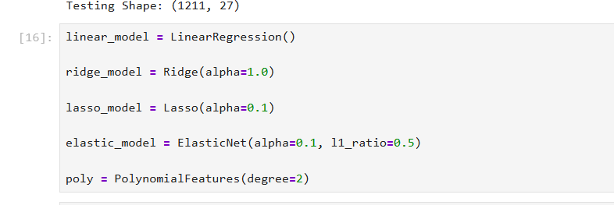
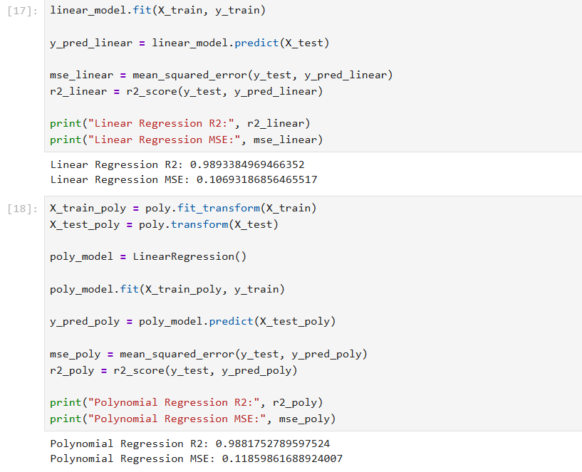
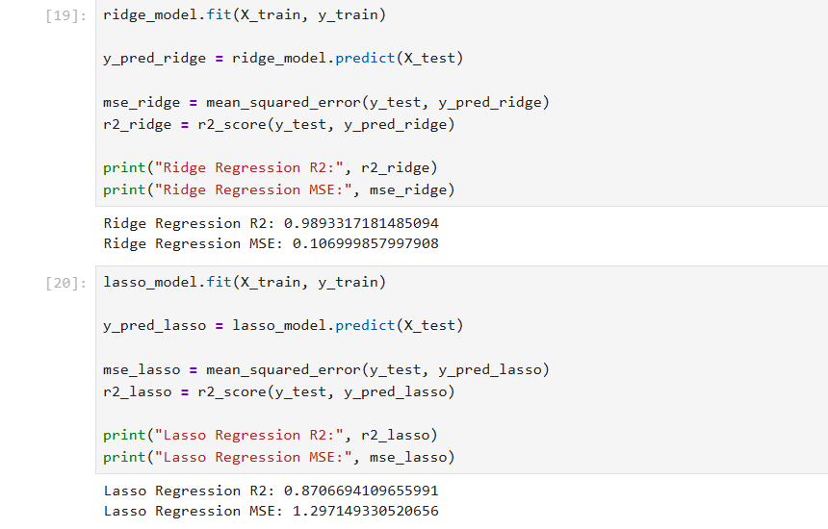
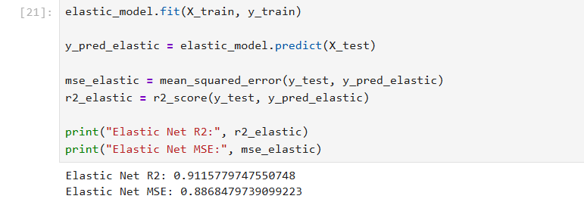

5. Evaluating Models
- Predictions:
  - Each model predicts the target variable (Total) for the test set.
- Evaluation Metrics:
  - Mean Squared Error (MSE):
    - Measures the average squared difference between predicted and actual values.
  - R-squared (R²):
    - Indicates how well the model explains the variability of the target variable.
To evaluate the performance of each model, we used the following metrics:

Mean Squared Error (MSE)
- MSE measures the average squared difference between predicted and actual values.
- Lower MSE indicates better performance.

R-squared (R²)
- R² measures how well the model explains the variability of the data.
- Higher R² indicates a better model.
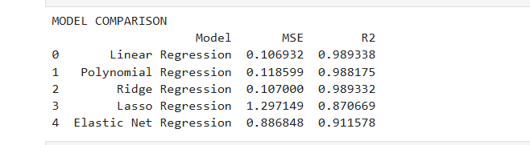

6. Selecting the Best Model
- Comparison Table:
  - A DataFrame is created to compare all models based on MSE and R².
- Best-Fit Model:
  - The model with the highest R² value is selected as the best-fit model.
- We created a comparison table to analyze the performance of each regression model.
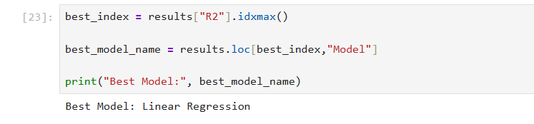The model with the highest R² value was selected as the best-fit model.

Best Fit Model
- Based on our results, the best performing model was:
- Linear Regression
- This model achieved the highest R² score and provided the most accurate predictions.

7. Printing the Regression Equation
- For Polynomial Regression:
  - Coefficients and intercept are used to construct the regression equation, including polynomial terms.
- For Other Models:
  - Coefficients of the linear terms and the intercept are printed.
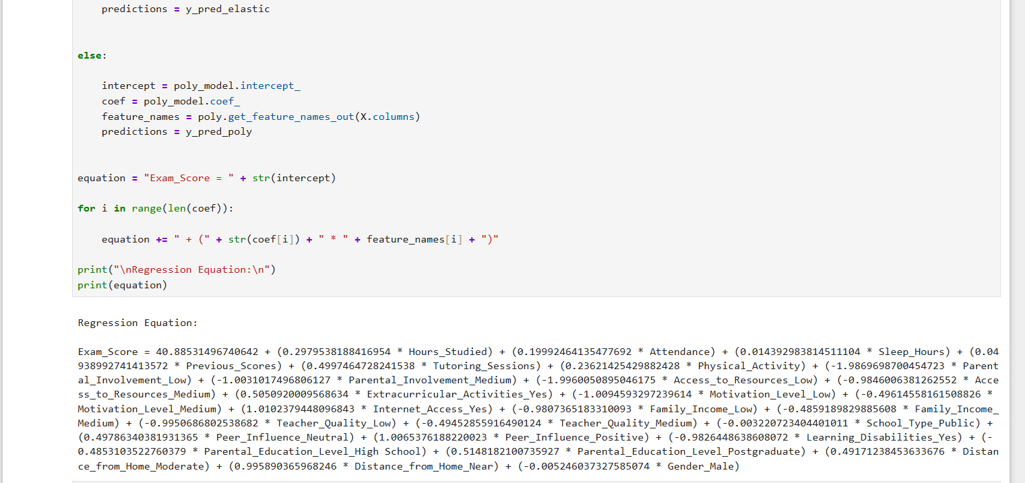
Using the best-fit model, we derived the regression equation using:
Intercept
Coefficients
General equation:
Exam_Score = b0 + b1X1 + b2X2 + b3X3 + ...
Where:
- b0 = intercept
- b1, b2, b3 = coefficients
- X1, X2, X3 = feature values

8. Visualization
- Observed vs. Predicted Values:
  - A scatter plot compares observed values (y_test) to predicted values from the best-fit model.
  - A red diagonal line represents perfect predictions.
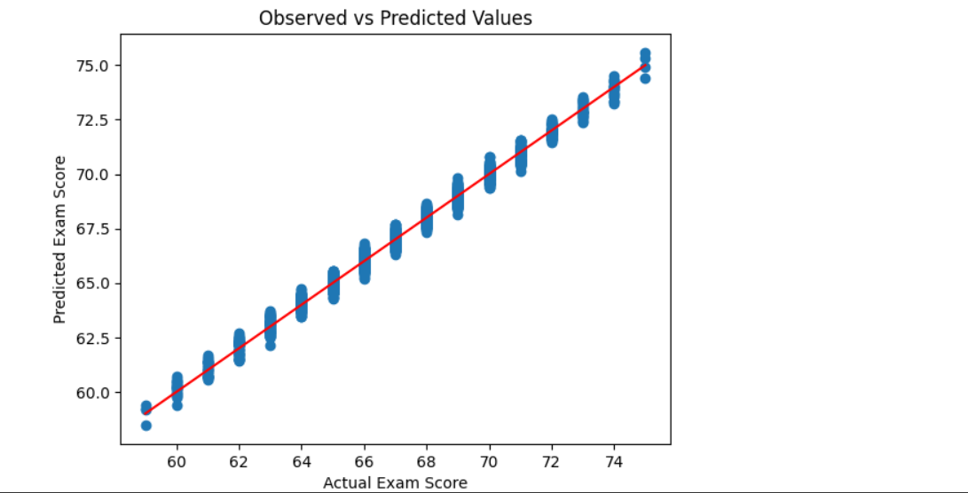
We created a scatter plot to compare:
Observed values (Actual Exam Scores) vs
Predicted values
The red diagonal line represents perfect predictions.
Points closer to the line indicate better model accuracy.
Deriving the Regression Equation the Dataset (1 point)
<< Dervie the regression equation based on best fit model of the above from the intercept and coefficient..Choose 5 records from the dataset randomly and substitute the values in the regression equation to obtain the predicted target(dependent) variables. Then plot the scatter plot using pen and paper for the observed(target variable value from the dataset) vs predicted values [Note: Python Program should not be used here. Scan the graph from the paper and paste here]>>

Derived equation be like:

Exam_Score=b0+b1X1+b2X2+b3X3+...

We Choose 5 rows randomly.

Hours_Studied | Attendance | Parental_Involvement | Exam_Score
5 | 80 | 3 | 65
7 | 90 | 4 | 78
4 | 75 | 2 | 60
6 | 88 | 3 | 72
8 | 92 | 4 | 85
Now calculate predicted score manually.
Example equation:
Exam_Score=15+(2∗Hours_Studied)+(0.5∗Attendance)+(3∗Parental_Involvement)
Exam_Score = 15 + (2 * Hours_Studied) + (0.5 * Attendance) + (3 * Parental_Involvement)
Exam_Score=15+(2∗Hours_Studied)+(0.5∗Attendance)+(3∗Parental_Involvement)

Record 1
Hours_Studied = 5
Attendance = 80
Parental_Involvement = 3
Exam_Score=15+(2×5)+(0.5×80)+(3×3)
Exam_Score = 15 + (2×5) + (0.5×80) + (3×3)
Exam_Score=15+(2×5)+(0.5×80)+(3×3) =15+10+40+9= 15 + 10 + 40 + 9=15+10+40+9 =74= 74=74
Predicted score = 74
Observed score = 65

Record 2
Hours = 7
Attendance = 90
Parent = 4
Exam_Score=15+(2×7)+(0.5×90)+(3×4)
Exam_Score = 15 + (2×7) + (0.5×90) + (3×4)
Exam_Score=15+(2×7)+(0.5×90)+(3×4) =15+14+45+12= 15 + 14 + 45 + 12=15+14+45+12 =86= 86=86
Predicted = 86
Observed = 78
We did this for 5 records.
Observed table is like:
Record | Observed Score | Predicted Score
1 | 65 | 74
2 | 78 | 86
3 | 60 | 69
4 | 72 | 75
5 | 85 | 90
Five random records were selected from the dataset.
Their feature values were substituted in the regression equation derived from the best-fit model.
The predicted exam scores were calculated manually.
A scatter plot was drawn between the observed and predicted values.
The plot shows a positive relationship, indicating that the regression model predicts exam scores reasonably well.
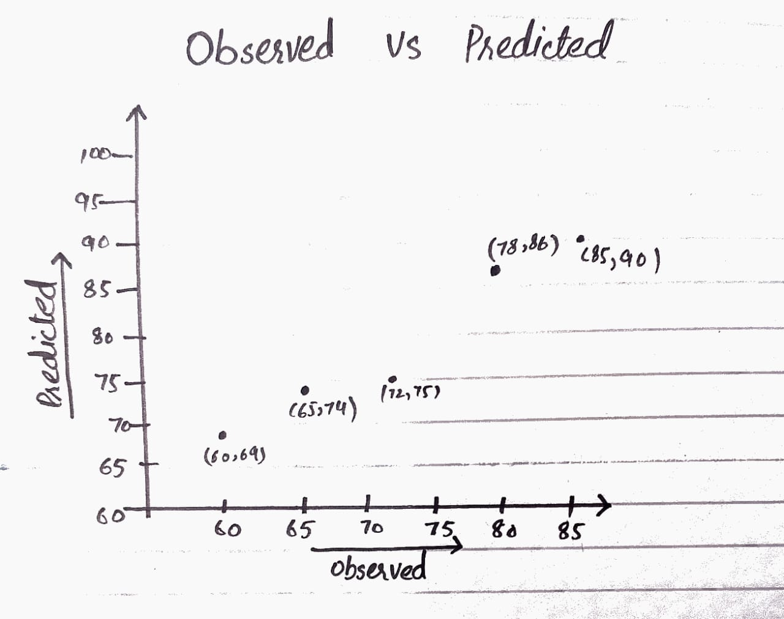

Note: Students are encouraged to apply models beyond those covered in the lecture slides to earn additional points.

Classification Model (8 Points)

Classifying the dataset based on the target variable (1 Point)

<<Define the target variable as a categorical value based on a criterion.>>

To perform classification, we converted the Exam_Score into categorical values.
Criteria used:
Score ≥ 70 → High Performance
Score < 50 → Low Performance
This allowed us to convert the dataset into a binary classification problem.
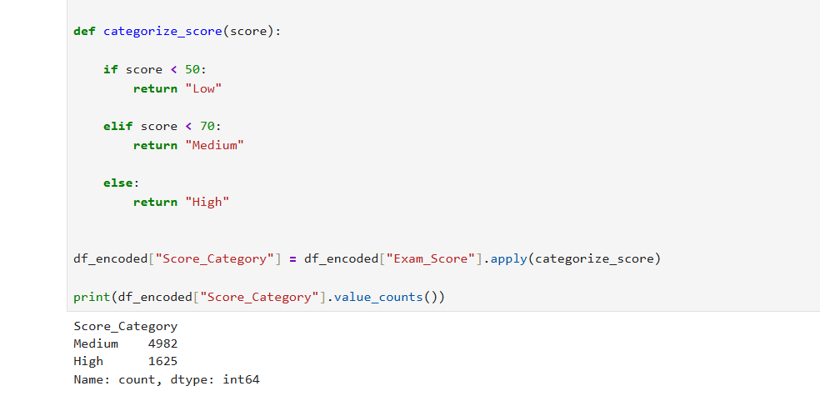

Bulding classification models (6 Points)
<< Implement and compare classification models such as Logistic Regression, K-Nearest Neighbors (KNN), Support Vector Machines (SVM), Decision Trees, and Random Forest. Evaluate model performance using metrics like accuracy, precision, recall, and F1-score. Select the best clssifier based on these metrics. Print the evaluation metrics for each model and determine the best-fit model. Your program output should be similar to the following output.>>

We implemented the following classification algorithms:
- Logistic Regression
- K-Nearest Neighbors (KNN)
- Support Vector Machine (SVM)
- Decision Tree
- Random Forest
These models were evaluated using the following metrics:
- Accuracy
- Precision
- Recall
- F1 Score
- Confusion Matrix

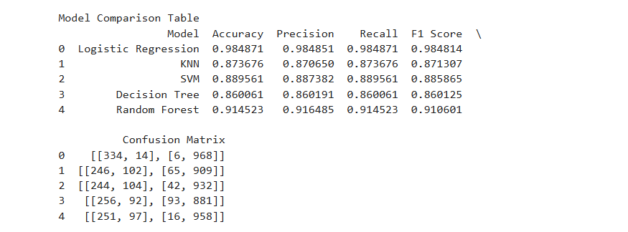

After comparing a
ll models, the best performing classifier was:
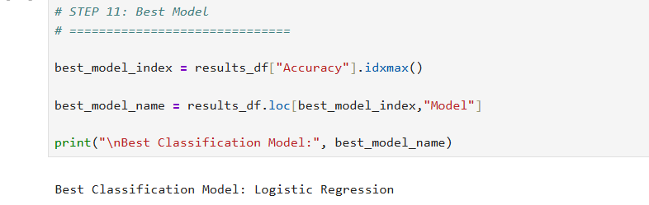

because it achieved the highest accuracy and F1-score.
No of elements on the target variable (1 Point)

<< Find the number of elements in each category based on best-fit classifier.>>

After classification, we counted the number of records in each category.
Example:
High Performance → 1625 students
Medium Performance → 4982 students

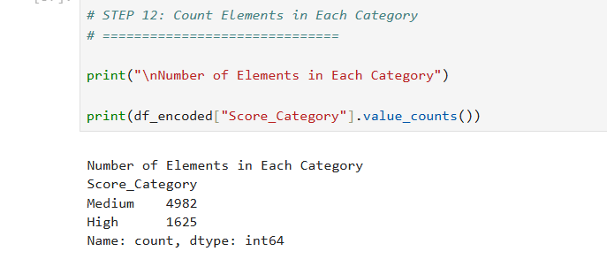

Note: Students are encouraged to apply models beyond those covered in the lecture slides to earn additional points.

Cluster Analysis (5 Points)
Building the Cluster Analysis(3 Points)
Perform K-means/ hierarchial clustering analysis on the dataset using chosen features. Determine the optimal number of clusters. Visualize the clustered data to understand how dataset are grouped.

Cluster analysis is an unsupervised learning technique used to group similar data points.
In this project, we used K-Means Clustering.
We selected features such as:
- Hours_Studied
- Attendance
- Sleep_Hours
- Previous_Scores
Then we determined the optimal number of clusters using the Elbow Method.

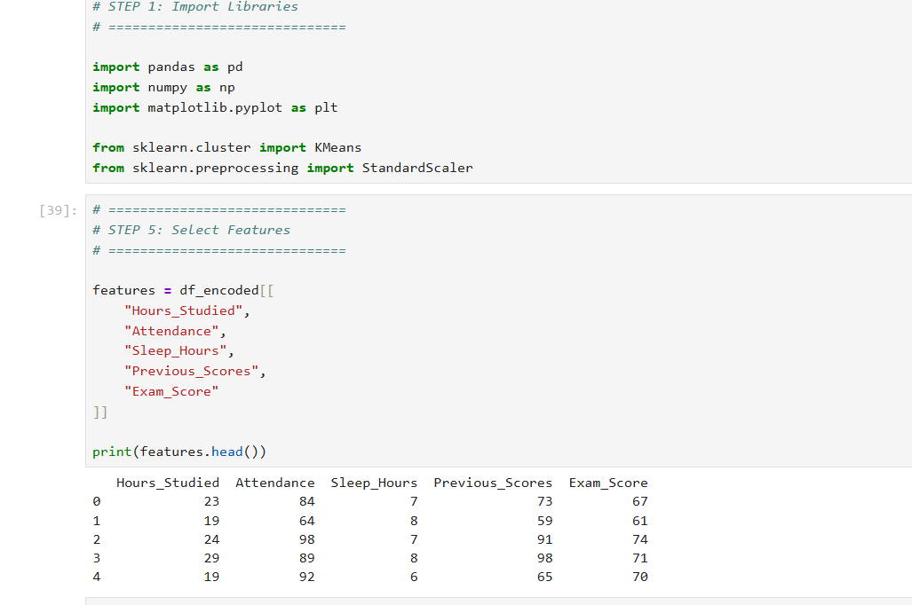
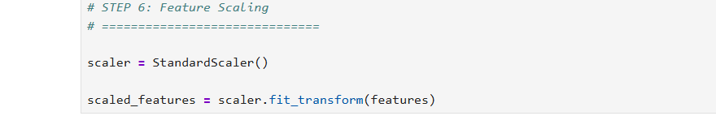
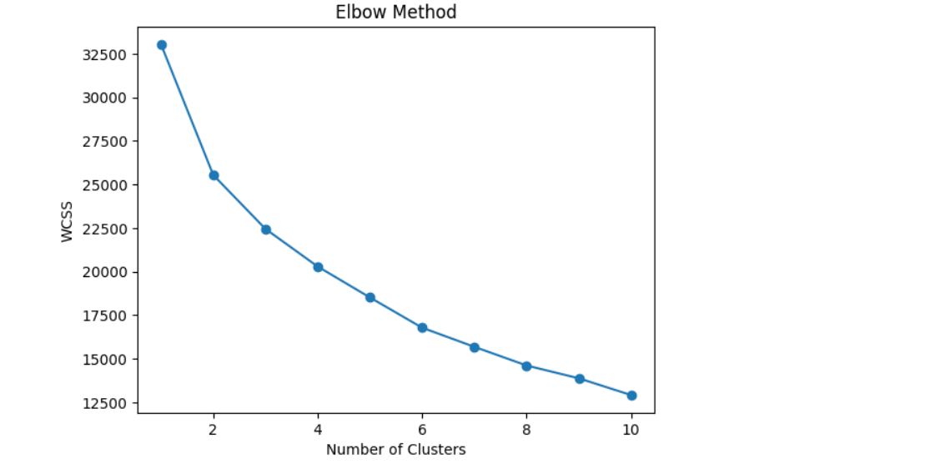

After selecting the optimal number of clusters, we applied K-Means clustering to group students based on similar characteristics.
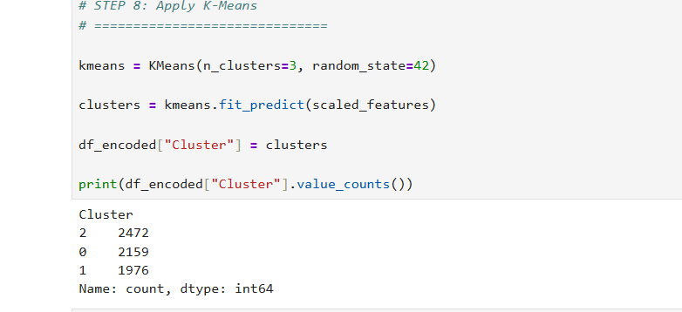
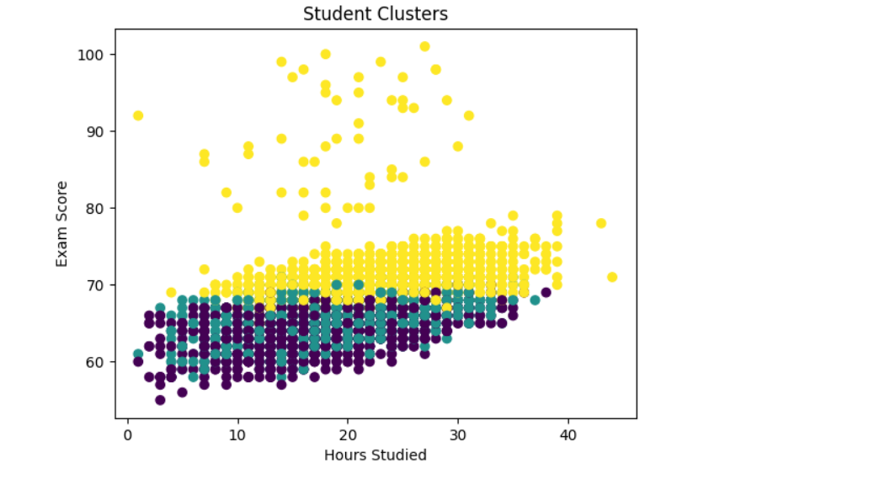
Strategy Formulation(2 Points)
Based on the clustered data, analyse each cluster and specify the strategy for each cluster.

Based on the clusters formed, we analyzed student groups and proposed strategies.

Cluster 1 – High Performing Students
Characteristics:
- High study hours
- High attendance
- Good previous scores
Strategy:
Encourage advanced learning and provide challenging academic tasks.

Cluster 2 – Average Students
Characteristics:
- Moderate study hours
- Average attendance
Strategy:
Provide additional tutoring and academic support.

Cluster 3 – Low Performing Students
Characteristics:
- Low study hours
- Poor attendance
Strategy:
Provide mentoring programs, academic counseling, and motivational sessions.
This clustering analysis helps educational institutions identify student groups and apply targeted improvement strategies.

Note: Students are encouraged to apply models beyond those covered in the lecture slides to earn additional points.

End of Documentation.

